Shem Fischer
English 2010
Memoir: High Octane Sports

At the age of four-teen I had a near death experience with a high octane sport. Fascinated with the art of flight I could not wait to break the shackles of gravity and fly free like a bird over the earth’s surface. I had little regard for the inherent danger and skills required to enjoy this sport in a safe manner.
It was a warm summer night as I made my way through the darkness to the small dirt landing strip locate five miles south of town. My heart pounded with excitement as the destination came into view aid by the light of a full moon. I could see the wind swept hanger and a few scattered structures trailing around the perimeter. My eyes were now glancing back and forth searching for the object that occupied each waking moment of my life.
At the age of twelve I begged my older brothers to take me flying as they trained for their solo licenses. I observed every move from the back seat and dreamed of flying by myself one day. In spite of several arguments I was always reminded I would have to wait until the age of six-teen to fly solo. 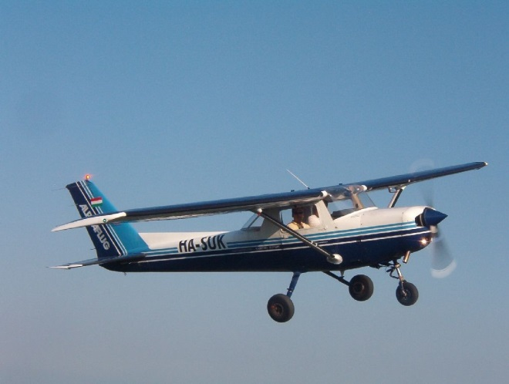
At the age of four-teen I could no longer wait. The image of the instructors Cesena 152 was prominent as I rounded the side of the old hanger. I retrieved the keys from the nail located behind a few old oil barrels and unlocked the door. Three tie downs were quickly removed and followed by a memorized pre-flight check. All instruments appeared to be in working order as I turned the prop over and fired up the engine. 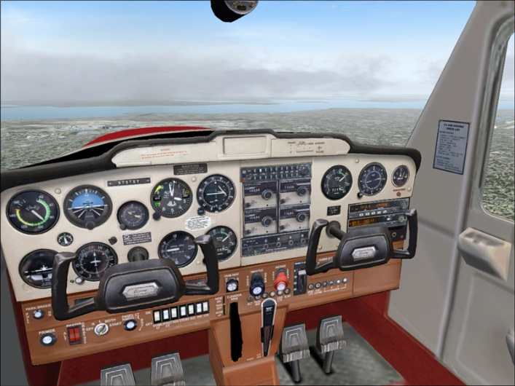
I became familiar with the functions of the plan by taxing up and down the moon lite dirt strip. Finally I got enough courage to taxi to the far end of the runway for a take-off. Locating the outline of the windsock I noticed a cross wind was blowing from the west. This would require an adjustment to the left flap and trim to compensate as soon as the plane became airborne to prevent snagging the barbwire fence. No problem I thought, I have seen all of this before. Throttle wide open the plane shuttered as it pick up speed. Two thirds from the end, it lifted and plunged toward the fence under control of the cross wind. Pulling back the yoke and driving the flaps in the opposite direction the plane was saved from an early demise. Back in control I guided the craft higher and higher over the rugged Arizona Strip. I was excited, liberated, and feared for my very life all at once.
I quickly realized the importance of three basic principles and how they safeguard the outcome of high octane sports. Properly employed these three principles provide personal safety and security to your equipment.
- Education
- Hands on training
- Safety equipment
According to the National Transportation Safety Board about 56% of all plane crashes are pilot error. Mechanical failure accounts for 20% of aviation accidents.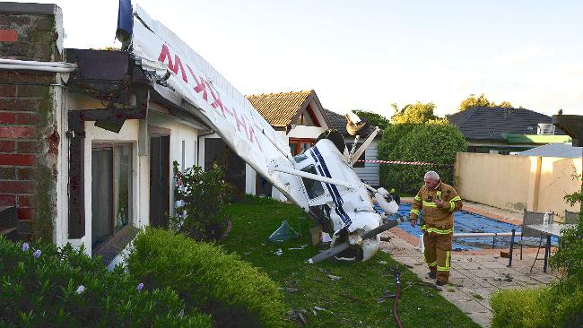
The remaining 24% are caused from weather and other related issues. The majority of all plan accidents occur at landing.
Flying solo for thirty minutes was a great experience. However, now I had to figure out how to land safely. I turned back form the north rim of the Grand Canyon and made my way back to the dirt landing strip to develop my approach and landing skills. Circling lower and lower I practiced several low passes. With new found confidence I decided I was ready for the final approach. The wind was still prevailing from the west, creating a dreaded cross wind across the dirt landing strip. The plane made contact about one-third way down the strip. Due to the rapid decent and not enough flair the craft bounced approximate fifteen feet in the air a few times before sticking the landing. With most of the runway used up, I romped on the breaks and flaps to reduce speed. Sliding dangerously close to the fence the plane came to rest in a cloud of dust with eighty feet of runway to spare. Education, training, and hand on experience play a direct impact on the end results. 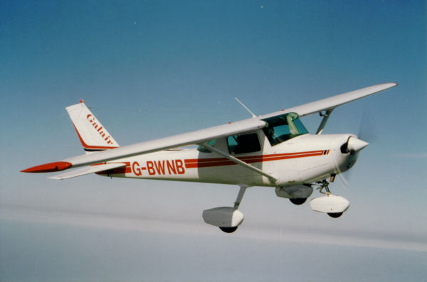
I had another experience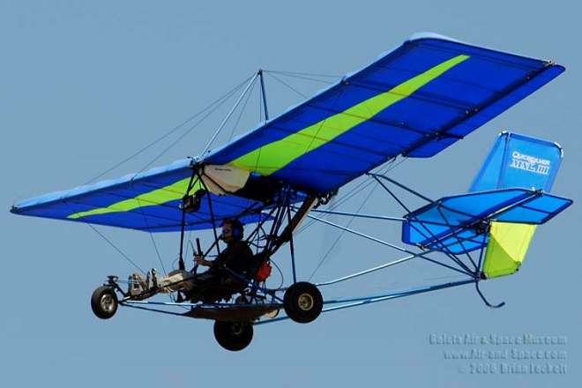 with an ultra lite at the age of 26. Me and my buddy could not afford a plane of our own so we restored an old ultra lite on a budget. Here again, eager to get into the air, we bi-passed education, hands on training and safety equipment. We managed to enjoy several flights with this old restored craft.
One windy summer afternoon my buddy decided to fly the ultra-light. He ascended to about 3,000 feet when a gust of wind flipped the craft upside down. This caused the craft to nose dive and spin out of control. I hear the impact one half a mile away and witnessed a large fire ball as the fuel cell burst into flames upon impact. We could not tell if he died from the impact or by the fire. Here again, the following three principals were ignored.
- Education
- Hands on experience
- Safety equipment
This responsibility becomes greater as we become adults. Our poor judgment now affects our dependents and others who count on us for a livelihood.
Your dream is out there, go get it…be safe.

